**Knights of Columbus Council 5301**

**Car Show**

**Apr 8th 2017**

**St Mary Magdalen School 6425 West Metairie Ave**

**Car Show Entry Fees will be donated to Wounded Warrior Project**

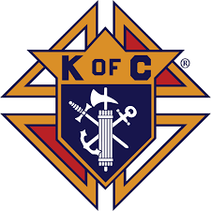

******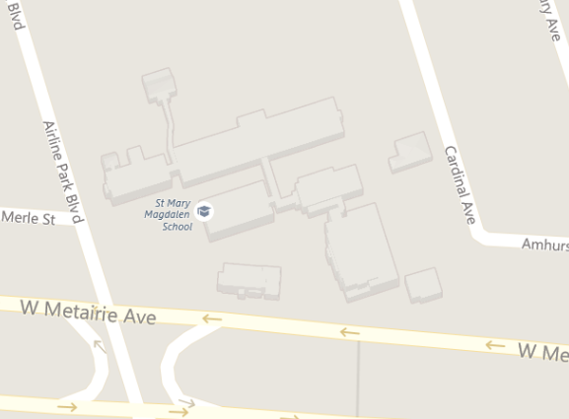**

**For Car Show info contact** [**johnnylatour@aol.com**](mailto:johnnylatour@aol.com) **,** [**john.latour@usmc.mil**](mailto:john.latour@usmc.mil) **or** [**kofc5301@gmail.com**](mailto:kofc5301@gmail.com) **http://stmarymagdalenchurch.com/**



11:30 am to 2:30 pm

50/50 tickets- $5.00 for 5 tickets, $10.00 for an arm length and $20.00 for a car length

**Entry Fee is $20.00 at the gate , but $15.00 if you pre-register by sending name , type of car and plate number to** [**john.latour@usmc.mil**](mailto:john.latour@usmc.mil) **by Mar 31st . No admission for spectators**

**Drinks**

**&**

**Food**

**Music**

**&**

**50/50**

Judging will be completed by your car peers and guest. We will have 1st , 2nd and 3rd place awards. First 10 cars get CarShow Glass Beer Mug and first 25 cars get dash plaques for event. 50/50 tickets will also go to a give away every 30 mintues.

No worry if you do not have a car, come see what HotRods are in the area , spend the day with us and take a chance on the 50/50 and free give aways

**Car Show will be held in the school’s field area and can be access from the Cardinal Ave Street parking lot.**

**If there is inclement weather, the car show will be cancelled**